COLERAINE HARBOUR EMERGENCY PLAN
(CHEP)

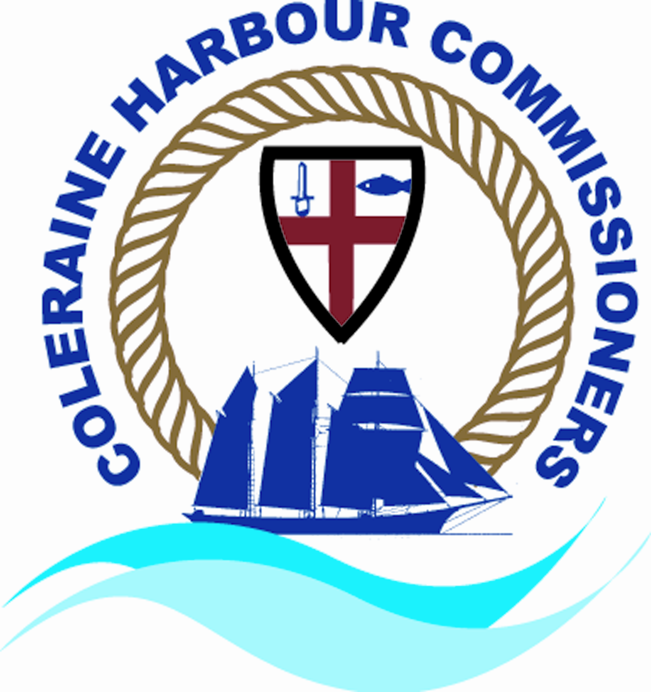

SEPTEMBER 2017

Coleraine Harbour Commissioners
4 Riversdale Road
Coleraine
BT52 1XA

Tel: 028 7034 2012
Fax: 028 7035 2000
Email: info@coleraineharbour.com
Website: www.coleraineharbour.com

COLERAINE HARBOUR EMERGENCY PLAN (CHEP)

Index
Amendment Records
Distribution List

- Introduction
- Grading of incidents
- Initiating authority
- Incident command post
- Co-ordination and overall in charge
- Communications
- Dealing with the media
- Clarifying payment/authorisation of services
- Roles & Responsibilities
- Essential telephone directory
- Resources & Equipment directory
- Various scenarios checklists
- Exercises & plan updates
- Port Plans

Plan Amendment Sheet for Coleraine Harbour Emergency Plan (CHEP)

Amendment No. | Date | Amended By | Brief Description of Amendment

Distribution of Copies

Copy Number:

- Coleraine Harbour Commissioners Harbour Office
- Marine Coastguard Agency
- Police Service
- Fire & Rescue Service
- Coleraine Coastguard
- Coleraine Community and Rescue Service
- Causeway Coast and Glens Borough Council

Address for External distribution:

Copy Number Address

- Coleraine Harbour Commissioners, Harbour Office, 4 Riversdale Road, Coleraine, BT52 1XA Tel: 028 7034 2012.
- Marine Coastguard Agency, Bregenz House, 5 Quay Street, Bangor, BT20 5ED, Tel : 028 9147 5310.
- Police Service, 17-19 Lodge Road, Coleraine, Tel: 028 7034 4122
- Fire & Rescue Service, 23-27 Lodge Road, Coleraine, BT52 1LU, Tel: 028 7034 2454.
- Coleraine Coastguard, 10 Gateside Business Park, Gateside Road, Coleraine, BT52 2PB, Tel: 028 7035 8314.
- Community Rescue Service, Kilcranny House, 21 Cranagh Road, Coleraine, BT51 3NN, Tel: 07711 233 802
- Causeway Coast and Glens Borough Council, Cloonavin, 66 Portstewart Road, Coleraine, BT52 1EY, Tel: 028 7034 7034.

CHEP

- Introduction

To comply with the Port Marine Safety Code (PMSC), Coleraine Harbour Emergency Plan (CHEP) have been developed and is part of the Coleraine Harbour Commissioners (CHC) Safety Management System (SMS). The plan has been developed to deal with any marine emergency or non routine incident occurring within the CHC area or jurisdiction. The plan is supplemented with Causeway Coast and Glens) Emergency Plan for their berths a copy of which is held by CHC.

Though various scenario action checklists have been formulated it is recognised every incident develops differently and it is not possible to plan for every contingency that may arise, therefore the plan remains flexible, but ensures that there is effective integrated action by the port authority, emergency services and other participants.

The priorities for action in an emergency are:

- Save life;
- Protect the environment;
- Protect property and safe navigation of the harbour;
- Contain and Stabilise

It is not the intention of the CHEP to take the place of any major disaster or other major incident arrangements made by the emergency services or local authorities.

The purpose if the CHEP is to ensure that the alarm is raised without delay, that early provision or pertinent information is made available and that there is proper control and direction of personnel and other resources available at the port in conjunction with those of the emergency services in order to provide a co-ordinated plan of action.

CHEP has been published after discussion and agreement with the principal parties who may be involved at anytime. The help and co-operation of all participants is gratefully acknowledged/

The CHC Oil Pollution Contingency Plan will also be initiated if necessary.

- Grading of Incidents

Class A CHEP An incident that can be dealt with by the resources readily available or where the initiation authority may need some assistance from one or more land based emergency services. No significant impact on land based authorities is anticipated.

Class B CHEP A major incident where there is expected to be a significant impact on land based authorities, where a multi agency tactical and operational level of control is considered necessary.

- Initiating Authority

In the event of an incident the Harbour Manager will be informed through various channels i.e. pilots, Coastguards, Police and public. The Harbour Manager will initiate CHEP if required.

- Incident Command Post (ICP)

Class A CHEP At the Harbour Office.

Class B CHEP At the Harbour Office.

The ICP may be relocated if deemed necessary by the multi agency command.

- Co-ordination of Emergencies

In an emergency incident, the land based services, Coastguard and Harbour Authority will liaise with each other as a multi agency command.

The Police Incident Commander will co-ordinate the land based emergency services and the Coastguard will co-ordinate the water search and rescue emergency services up stream as far as Seatons Marina. The Police will co-ordinate water search up stream of Seatons Marina.

- Communications

VHF CHANNEL USE

Ch 16 Distress
Navigation Warnings
Ch 12 Coleraine Harbour
Routine
Ch 0 & 67 Coastguard Search and Rescue.

- Dealing with the Media

The local media briefing area will be provisionally at the Harbour Managers Office, 4 Riversdale Road, Coleraine, Co. Londonderry, BT52 1XA.

Where there is a multi-agency response, CHC will liaise with other agencies regarding media briefings. The police will co-ordinate this operation.

- Clarifying Payment / Authorisation of Services

When services of contractors are engaged i.e. divers, salvage officers etc clarification of who has appointed these services should be clear. i.e. ship owner or master (possibly through shipping agent), port authority etc.

- Roles and Responsibilities

CHC

CHC have the responsibility for the safety of navigation within their area of jurisdiction. They have conservancy and regulatory functions with specific powers to regulate the control and movement of all vessels. The Harbour Manager has powers to give directions to particular ships on particular occasions. CHC has the power to lay down general rules for the movement of shipping prescribed in local harbour byelaws and notices and does so.

Harbour Manager

Under section 1 of the Dangerous Vessel Act 1985 a Harbour Manager can direct a vessel to leave the port or remain outside the port if in his opinion the vessel or its contents might in any way pose a threat to the safety of persons or property. Specifically if its presence in the harbour might involve:

- Grave and imminent danger to the safety of any person or property or
- Grave and imminent risk that the vessel may be sinking or foundering and thus prevent or seriously prejudice the use of the harbour by other vessels.

NB: The Secretary of State or his Representive can override the Harbour Manager’s ruling on the vessel and require it to enter the port or move as he so instructs.

Maritime & Coastguard Agency

Is responsible for both the co-ordination of civil maritime Search & Rescue and Counter Pollution operations in UK waters.

Community Rescue Service

Is responsible for the co-ordination of search and rescue emergencies upstream from Seatons Marina.

Police Service

PSNI will work with multi-agency partners in line with the Joint Emergency Services Interoperability Principles to:

- Protect life and property
- Preserve order
- Prevent the commission of offence; and
- Where an offence has been committed, to take measures to bring the offender to justice.

Where required the PSNI will also act as agents of the Coroner in the investigation of sudden or unexpected deaths.

Fire & rescue Service

- To preserve life and safeguard property;
- Fire fighting;
- Rescue of persons trapped;
- Emergency containment of hazardous substances;
- Other special service duties which may be required, dependent upon the incident;
- Coleraine Fire and Rescue Service have a legal requirement to attend fires within the Coleraine area.

Ambulance Service

- To preserve life in conjunction with other emergency services;
- To treat and care for those injured at the scene, either directly or in conjunction with medical personnel;
- To provide and Ambulance Incident Officer at the incident command post;
- Arrange conveyance of casualties and persons from the scene of the incident to designated hospitals.

Causeway Coast and Glens Borough Council

In a major emergency the functional role of local authorities is to support the emergency services during the ‘lifesaving phase’ and to provide those services it considers required for the well being of those in distress. Causeway Coast and Glens Borough Council could also be involved in the recovery phase of any incident.

Causeway Coast and Glens Borough Council) has their own Emergency Plans for major emergencies, flooding and oil pollution.

When called upon by the emergency services, Causeway Coast and Glens Borough Council will respond in accordance with its own arrangements and procedures, which include;

- Sending an officer to the multi agency command post;
- Assisting the police at evacuation assembly points (EAPs);
- Assisting and coordinatind transport from the EAPs to emergency rest centres (ERCs)
- Opening and managing ERCs;
- Assisting the police and friends and relative reception centres;
- Activating their own emergency centre, if required;

- Various Scenario Checklists

It is recognised that each emergency will have an unique combination of circumstances and the most effective response will depend on a degree of flexibility. These checklists have been formulated to suggest what possible action may be taken in the most likely emergency situations:

ESSENTIAL TELEPHONE DIRECTORY

Name Telephone Mobile Fax

Coleraine Harbour Office 028 7034 2012 028 7035 2000

Harbour Manager
Lisa McLaughlin 028 7034 2012 07742242788 028 7035 2000

Police 999

Fire & Rescue 999

Ambulance 999

Marine Coastguard Agency
Bangor 028 9147 5310

Causeway Coast and Glens Borough Council 028 7034 7034

Causeway Coast and Glens Borough Council
Duty Emergency Officer
(Outside Working Hours) 07850 570 763

Coleraine Harbour Staff:

Stephen McLaughlin Pilot 07921 361 459

Robert Garvin Pilot 07759 402 866

Community Rescue Service 07711233802

Divers:

Aquaholics Richard Lafferty 07968 164 748

Inwater Services Alfie Hunt 07715 569 695

Crane Hire Companies:

Quigleys Crane Hire 028 777 50470

Castle Engineering and Crane Hire 028 7084 8614

Resource and Equipment Directory

Watercraft

Confidencce 16m Delta Tug

Ulidia 10.78m Work Boat/Pilot Vessel

Sea Rover 6m Work Boat

Fork Lift Trucks

- Working Loads between 4 & 5 tonnes

Crane

- Crawler Crane SWL 18 tonne

Oil Pollution Equipment

Tier 1 Resources held at Coleraine Harbour

Tier 2 Resources held at Braemar Howells Depot Belfast

Index

- Grounding of Vessel
- Collision or emergency involving vessels and structures (Quays, Piers, Bridge) in the harbour
- Fire or explosion of any vessel at moorings or underway
- Vessel approaching the harbour on fire, or in danger of sinking, or having sustained damage hazarding the vessel.
- Fire or explosion on a vessel alongside the quay
- Fire or explosion on a quay.

- Grounding of Vessel

- Evaluate situation, determine assistance required, inform appropriate emergency services.
- Check for missing persons & casualties, administer first aid
- Keep unwanted traffic & persons clear
- Check vessel for damage ; sound bilges, tanks etc
- Apply necessary damage control.
- Check for pollution, apply oil contingency plan if necessary.
- Check if Dangerous Cargo is onboard and act accordingly.
- Avoid: stresses to vessel, capsize, breaking vessels back, sinking, etc
- Assess tide, flooding or ebbing.
- Decide whether to move vessel, or anchor vessel and await higher tide.
- Use available tugs and workboats as required.
- Check actual draft of vessel, compare to proper floating draft of vessel to determine how much aground
- Trim vessel: transfer ballast or weights, ballast, deballast, etc
- Lighten vessel: remove cargo etc.
- Inform all necessary personnel in CHEP telephone directory.
- Arrange all required equipment (Resources/equipment directory refers).

- Collision or emergency involving vessels and structures (Quay, Piers, Bridge) in the harbour

- Evaluate situation, determine assistance required appropriate emergency services.
- Check for missing persons and casualties, administer first aid.
- Keep unwanted traffic and personnel clear
- Check vessel for damage, sound tanks, bilges etc.
- Apply necessary damage control: Pumps, heeling/trimming v/l, wedges etc.
- Check for pollution and apply oil pollution contingency plan if necessary.
- Check if dangerous cargo is onboard and act accordingly.
- Avoid vessel sinking in navigation channel.
- Decide whether to: move vessel to shallow water / beach vessel / or secure vessel alongside berth, etc.
- Inform all necessary personnel in CHEP telephone directory.
- Arrange all required equipment. (Resources/equipment directory refers).

- Fire or Explosion on any vessel at moorings or underway

- Evaluate situation, determine assistance required and inform appropriate emergency services.
- Check for missing persons and casualties, administer first aid.
- Keep unwanted traffic and personnel clear
- Check vessel for damage, sound tanks, bilges etc.
- Apply necessary damage control: Pumps, heeling/trimming v/l, wedges etc.
- Extinguish fire.
- Check for pollution and apply oil pollution contingency plan if necessary.
- Check if dangerous cargo is onboard and act accordingly
- Avoid vessel sinking in navigation channel.
- Decide whether to: move vessel to shallow water / beach vessel / or secure vessel alongside berth, etc
- Inform all necessary personnel in CHEP telephone directory.
- Arrange all required equipment. (Resources/equipment directory refers).

- Vessel approaching the harbour on fire or on danger of sinking, or having sustained damage hazarding the vessel.

Permission to enter the harbour will be decided by the Harbour Manager, who will carry out a risk assessment to determine whether it is safe to enter, and if so, how the operation should be carried out.

NB: The Secretary of State can override the Harbour Managers decision. (Dangerous Vessels Act 1985 referS)

- Fire or explosion on a vessel alongside a quay

- Evaluate situation, determine assistance required and inform appropriate emergency services.
- Rescue survivors and causalities, administer first aid.
- Determine if dangerous cargo/substances onboard or in vicinity and act accordingly.
- Activate oil pollution contingency plan if necessary.
- Provide access for emergency services
- Clear area of traffic and personnel and other vessels.
- Extinguish Fire
- Avoid sinking or capsizing of vessel
- Liaise with emergency services on their arrival
- Inform all necessary personnel in the CHEP telephone directory.
- Arrange all required equipment. (Resources/equipment directory refers)

- Fire or explosion on quay

- Evaluate situation, determine assistance required and inform appropriate emergency services
- Rescue survivors and casualties, administer first aid.
- Determine if dangerous cargoes in area
- Activate oil pollution contingency plan if necessary
- Provide access for emergency services
- Clear area of traffic, personnel and shipping.
- Extinguish Fire
- Hand over to emergency services on their arrival
- Inform all necessary personnel in the CHEP telephone directory
- Arrange all required equipment. (Resources/equipment directory refers).

- Exercises and Plan Updates

Exercises:

- Annually Internal alerting exercise or incident.

- Bi-Annually An exercise or incident deploying CHC resources.

- As Required An exercise or incident involving other organisations.

A log of these exercises and incidents is maintained in the form the Incident and the Exercise Log kept in the Harbour Managers office.

Plan updates:

The plan will be maintained and updates by the Harbour Manager.

PORT PLANS

Chart showing Pilotage areas.

Area of Operation - River Bann to Coleraine

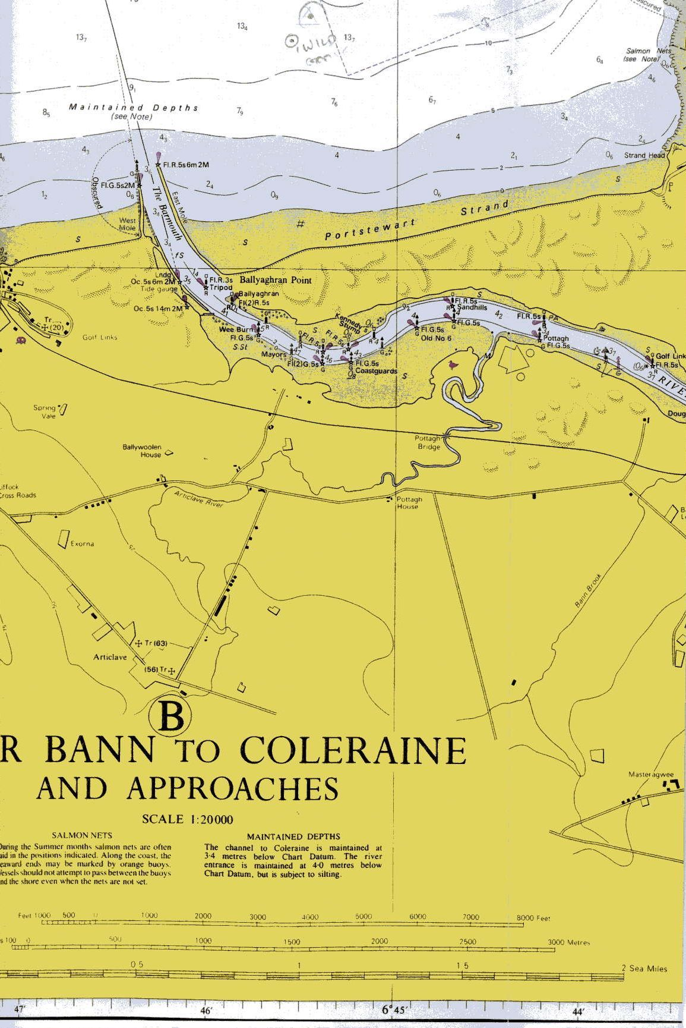

Area of Operation - River Bann to Coleraine



